**Assignment no – 16-C2**

**Problem Definition:**

To perform using xen hypervisor or equivalent open source to configure it.Give necessary GUI

**Prerequisites:**

* Setup of Xen
* Setup of VM Workstation
* Setup of WinSCP

**1.1 Learning Objective:**

* Study and installation of Hypervisor

**1.2 Theory:**

A hypervisor, also called a virtual machine manager, is a program that allows multiple operating systems to share a single hardware host. Each operating system appears to have the host's [processor](http://searchcio-midmarket.techtarget.com/definition/processor) , [memory](http://searchmobilecomputing.techtarget.com/definition/memory) , and other resources all to itself. However, the hypervisor is actually controlling the host processor and resources, allocating what is needed to each operating system in turn and making sure that the guest operating systems (called virtual machines) cannot disrupt each other.The hypervisor lets you show the same application on lots of systems without having to physically copy that application onto each system. One twist: Because of the hypervisor architecture, it can load any (or many) different operating system as though it were just another application. Therefore, the hypervisor is a very practical way of getting things virtualized quickly and efficiently.

**Defining types of hypervisors in cloud computing**

Different hypervisors support different aspects of the cloud. Hypervisors come in several types:

* Native hypervisors, which sit directly on the hardware platform are most likely used to gain better performance for individual users.
* Embedded hypervisors are integrated into a processor on a separate chip. Using this type of hypervisor is how a service provider gains performance improvements.
* Hosted hypervisors run as a distinct software layer above both the hardware and the OS. This type of hypervisor is useful both in private and public clouds to gain performance improvements.

**Xen Hypervisor:**

Xen Project is a [hypervisor](https://en.wikipedia.org/wiki/Hypervisor) using a [microkernel](https://en.wikipedia.org/wiki/Microkernel) design, providing services that allow multiple computer [operating systems](https://en.wikipedia.org/wiki/Operating_system) to execute on the same [computer hardware](https://en.wikipedia.org/wiki/Computer_hardware) concurrently.

The [University of Cambridge Computer Laboratory](https://en.wikipedia.org/wiki/University_of_Cambridge_Computer_Laboratory) developed the first versions of Xen. The Xen Project community develops and maintains Xen Project as [free and open-source software](https://en.wikipedia.org/wiki/Free_and_open-source_software), subject to the requirements of the [GNU General Public License](https://en.wikipedia.org/wiki/GNU_General_Public_License) (GPL), version 2. Xen Project is currently available for the [IA-32](https://en.wikipedia.org/wiki/IA-32), [x86-64](https://en.wikipedia.org/wiki/X86-64) and [ARM](https://en.wikipedia.org/wiki/ARM_architecture) [instruction sets](https://en.wikipedia.org/wiki/Instruction_set).

**Software architecture:**

Xen Project runs in a more privileged CPU state than any other software on the machine.

Responsibilities of the hypervisor include memory management and CPU scheduling of all virtual machines ("domains"), and for launching the most privileged domain ("dom0") - the only virtual machine which by default has direct access to hardware. From the dom0 the hypervisor can be managed and unprivileged domains ("domU") can be launched.

The dom0 domain is typically a version of [Linux](https://en.wikipedia.org/wiki/Linux) or [BSD](https://en.wikipedia.org/wiki/NetBSD). User domains may either be traditional operating systems, such as [Microsoft Windows](https://en.wikipedia.org/wiki/Microsoft_Windows) under which privileged instructions are provided by hardware virtualization instructions (if the host processor supports [x86 virtualization](https://en.wikipedia.org/wiki/X86_virtualization), e.g., [Intel VT-x](https://en.wikipedia.org/wiki/Intel_VT-x) and [AMD-V](https://en.wikipedia.org/wiki/AMD-V)), or *para-virtualized* operating systems whereby the operating system is aware that it is running inside a virtual machine, and so makes hypercalls directly, rather than issuing privileged instructions.

Xen Project boots from a [bootloader](https://en.wikipedia.org/wiki/Bootloader) such as [GNU GRUB](https://en.wikipedia.org/wiki/GNU_GRUB), and then usually loads a [paravirtualized](https://en.wikipedia.org/wiki/Paravirtualization) host operating system into the host domain (dom0).

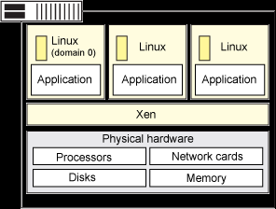

**which type does it belongs:**

Xen is primarily a bare-metal, type-1 hypervisor that can be directly installed on computer hardware without the need for a host operating system. Because it's a type-1 hypervisor, Xen controls, monitors and manages the hardware, peripheral and I/O resources directly. Guest virtual machines request Xen to provision any resource and must install Xen virtual device drivers to access hardware components. Xen supports multiple instances of the same or different operating systems with native support for most operating systems, including Windows and Linux. Moreover, Xen can be used on x86, IA-32 and ARM processor architecture.

**Steps to install:**

1. Login as the root and type the following commands:  
# yum install xen virt-manager kernel-xen  
# chkconfig xend on  
# reboot

Make sure you boot CentOS server using XEN kernel.

2.How do I install NetBSD / any Linux distro / Windows 2000 inside XEN?

Simply use gui tool called virt-manager:  
# virt-manager &

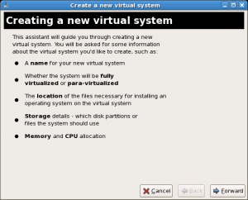

3.Installing CentOS 5.3 guest using the Internet

virt-install is a command line tool for provisioning new virtual machines using the “libvirt” hypervisor management library. Type the following command to install CentOS v5.3 64 bit as guest operating system in /vm:  
# mkdir /vm  
If you are using SELinux, enter:  
# semanage fcontext -a -t xen_image_t "/vm(/.*)?"  
# restorecon -R /vm  
# ls -dZ /vm

4.Above will provide security context of Xen images. Finally, install CentOS 5.3 using the Internet mirror:  
# virt-install \  
--paravirt \  
--name webserver01 \  
--ram 512 \  
--file /vm/webserver.nixcraft.com.img \  
--file-size 10 \  
--nographics \  
--location http://mirrors.kernel.org/centos/5.3/os/x86_64/  
  
Above will CentOS as a paravirtualized Xen guest, with 512 MB of RAM, a 10 GB of disk, and from a web server, in text-only mode. You need to just follow on screen instructions.

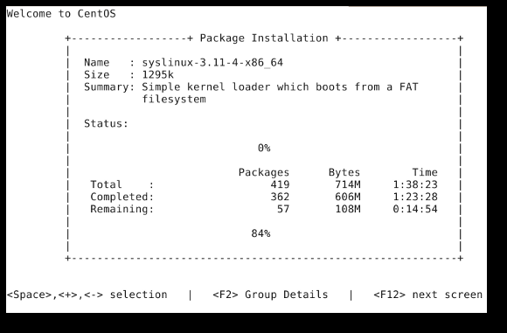

5.Once installed you can use xm command to list, start, stop and manage xen vps:  
# xen list.

**Conclusion-** understands and hands on Installation of Xen Hypervisor

**Outcome-**

**Upon completion Students will be able to:**

**ELO17:** understand the use of hypervisor in virtualization and Demonstrate the Xen Hypervisor. 

**Questions:**

* + 1. What is hypervisor?
    2. Explain virtualization in cloud?
    3. Types of hypervisor?
    4. Use of hypervisor in cloud?